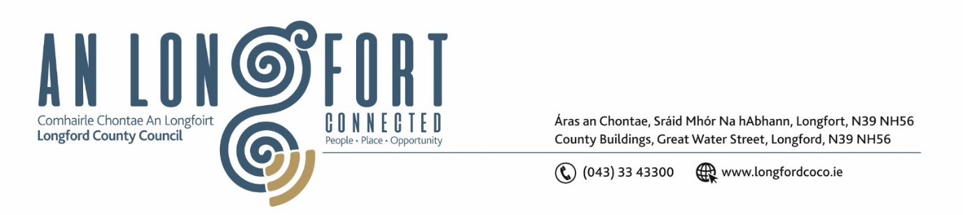

**GRANARD MUNICIPAL DISTRICT**

***Please note meeting will be held in Granard Library.***

**15 May 2023.**

**To: Each Member of Granard Municipal District.**

**Dear Member,**

You are requested to attend a Meeting of Granard Municipal District to be held in Granard Library on **Tuesday 23rd May 2023 at 3.30pm** to transact business, as set out on the Agenda hereunder.

**Yours sincerely**,

______________________

**Claire McNabola,**

**Meetings Administrator**

**AGENDA**

Prayer before meeting.

**1.** Confirmation of Minutes as follows: -

1. Granard Municipal District Meeting held on 24 March 2023 – enclosed.
2. Granard Municipal District Committee Meeting held on 24 March 2023 – enclosed.

**2.** Matters arising from Minutes.

**3.** Declaration of Interest by Members.

**4.** Management Report incorporating Area Engineer’s Progress Report – to follow.

**5.** Community Grant Support Scheme 2023 – to follow

**6.** Special Projects/Discretionary Grants 2023 – to follow

**7. Notices of Motions, submitted by Councillors, as listed hereunder:**

**Councillor Paraic Brady**

I call on Longford Roads section to mark the crossroads at Hagan’s cross in Killoe and put a single white line up into and beyond the village and if possible as far as the national school in Killoe. This stretch of road allows people to pass going through the village where there's a pub, church, shop and play area.

**Councillor PJ Reilly**

I wish to put a motion to the meeting for the Council to write to TII Roads Authority to construct a relief road on the N55 on the Cavan North side of the town of Granard to connect with the Athlone South side of the town to help to relieve the large amount of congestion and heavy traffic passing through the town.

**Councillors Colin Dalton and Paraic Brady (joint motion)**

We call on Longford County Council through the Regeneration team to refresh the walkway on Cairn Hill.

**Councillors Colin Dalton**

1. I call on Longford County Council to distribute the funding that was allocated in budget to maintain our walkways.
2. I call on Longford County Council to repair any damaged road signs in the Killoe, Ballinalee, and Clonbroney areas.

**Councillor Turlough McGovern**

I call on Longford County Council to write to Minister Darragh O’Brien to highlight the current crisis in recruitment and retention of Retained Firefighters, especially in Granard which ultimately lies with Government policy, and seek an increase in capital investment for County Longford.

The current conditions offer little incentive for new recruits to the retained fire service, and it is seen by many as a thankless role with little or no personal benefit.

The current crisis in retention and recruitment is forcing Retained Firefighters to work extra hours to make up for staffing shortages, understaffing or delayed response times putting the public at serious risk. This was discussed in the Dáil in November 2022 with no change six months later.